**Table of Contents:**

1. USE CASE DIAGRAM: 1

1.1 High level use case description: 2

1.2 Expanded level use case description: 7

2. SEQUENCE DIAGRAM: 15

2.1 Sequence diagram of Registration: 15

2.2 Sequence diagram of Product, Add to cart, and Product Ordering: 16

1.1 Sequence diagram for Admin Dashboard: 17

3. DATA FLOW DIAGRAM: 18

3.1 Context Diagram – Level 0 DFD 18

3.2 Level 1 DFD 19

4. CLASS DIAGRAM: 20

5. ACTIVITY DIAGRAM: 21

5.1 Activity Diagram – Customer 21

5.2 Activity Diagram – Admin 22

6. ENTITY RELATIONSHIP DIAGRAM: 23

7. ARCHITECTURE OF THE SYSTEM: 24

8. WIREFRAMES: 25

8.1 Admin Wireframe 25

8.2 Customer Wireframe 36

**Table of Figure:**

Figure 1: Use case diagram 2

Figure 2: Sequence diagram of Registration 15

Figure 3: Sequence of Product, Cart, and Product Ordering 16

Figure 4: Sequence Diagram of Admin Dashboard 17

Figure 5: Context Diagram - Level 0 DFD 18

Figure 6: Level 1 DFD 19

Figure 7: Class Diagram 20

Figure 8: Activity Diagram - Customer 21

Figure 9: Activity Diagram - Admin 22

Figure 10: Entity Relationship Diagram 23

Figure 11: System Architecture 24

Figure 12: Admin - Dashboard 25

Figure 13: Admin - Order page 26

Figure 14: Admin - Add Products 27

Figure 15: Admin - Product List 28

Figure 16: Admin - Review Page 29

Figure 17: Admin - User List 30

Figure 18: Admin – Profile 31

Figure 19: Admin - Edit Profile 32

Figure 20: Admin - Change Password 33

Figure 21: Admin - Registration Signup 34

Figure 22: Admin - Registration Login 35

Figure 23: Home Page 36

Figure 24: Product Description 37

Figure 25: Cart Page 38

Figure 26: Order List 39

Figure 27: Registration - Sign Up 40

Figure 28: Registration - Sign in 41

Figure 29: Profile 42

Figure 30: Profile - Edit Profile 43

Figure 31: Profile - Change Password 44

# USE CASE DIAGRAM:

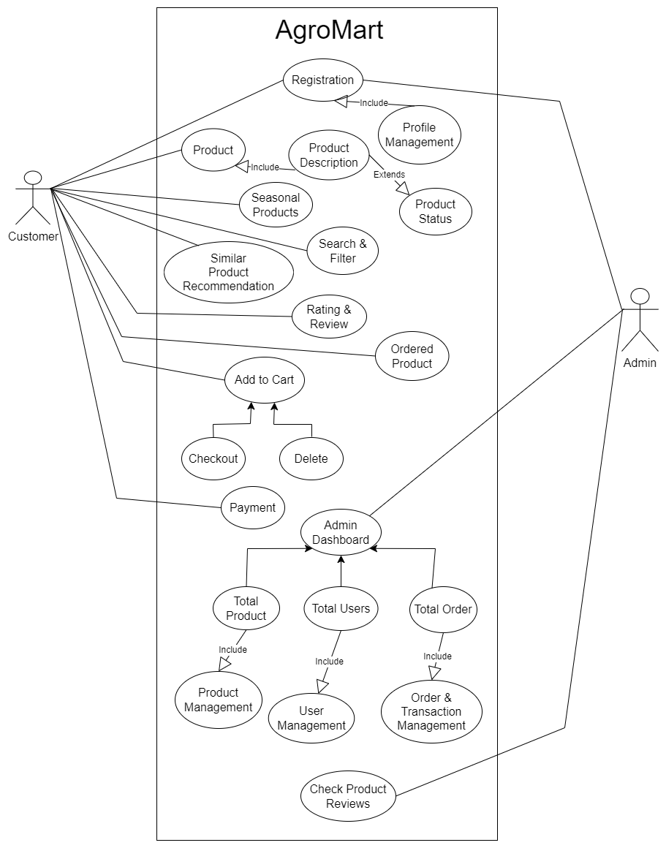

Figure 1: Use case diagram

## High level use case description:

1. **High level description of register use case:**

**Use case:** Register

**Actor:** Customer, Admin (initiator)

**Description:** A new customer and new admin should register to take full functionality over the AgroMart app.

1. **High level description of Profile Management Use Case:**

**Use Case:** Profile Management

**Actor:** Customer, Admin

**Description:** A customer and an admin can edit their details after register on the system.

1. **High level description of product use case:**

**Use case:** Product

**Actor:** Customer

**Description:** A customer can navigate through the products page and can select their products to order.

1. **High level description of Product Description Use case:**

**Use case:** Product description

**Actor:** customer (initiator)

**Description:** A customer can view more about the products by clicking on the specific project so, the product description page will be open and can look toward the details of the products.

1. **High level description of seasonal products use case:**

**Use case:** Seasonal Products

**Actor:** Customer (initiator)

**Description:** A customer can look forward to the seasonal products so, they can easily navigate through the seasonal products.

1. **High level description of search and filter products use case:**

**Use Case:**  Search and Filter

**Actor:** Customer (initiator)

**Description:** To save time a customer and directly search for the products and can filter the products as per their requirement.

1. **High level description of rating and review use case:**

**Use case:** Rating and Review

**Actor:** Customer

**Description:** A customer can rate and review the products they used and can leave their message so the other customer can look the review before buying the products.

1. **High level description of ordered product use case:**

**Use case:** product Order

**Actor:** Customer

**Description:** A customer can view the product which they ordered to buy the products in Ordered Products page.

1. **High level description of Similar Product Recommendation use case:**

**Use Case:** Similar Product Recommendation

**Actor:** Customer

**Description:** A customer can view the similar products in the description page.

1. **High level description of AddToCart use case:**

**Use Case:** AddToCart

**Actor:** Customer

**Description:** A customer can add the products in the cart so, that they can order the products as per their requirement.

1. **High level description of AddToCart use case:**

**Use Case:** AddToCart

**Actor:** Customer

**Description:** A customer can add the products in the cart so, that they can order the products as per their requirement.

1. **High level description of Payment use case:**

**Use Case:** Payment

**Actor:** Customer

**Description:** A customer should pay the money for the products which they order to buy.

1. **High level description of Admin Dashboard use case:**

**Use case:** Admin dashboard

**Actor:** Admin

**Description:** Admin dashboard shows the information about the total products, total registered user, and total order. Where admin can manage all this information accordingly.

1. **High level description of Check product reviews use case:**

**Use Case:**  Check Product reviews

**Actor:** Admin

**Description:** Admin can view the product rating and review which was provided by the customer.

## Expanded level use case description:

1. **Expanded description of Registration use case:**

**Use case:** Registration

**Actor:** Customer, Admin (Initiator)

**Purpose:** To register the users in system

**Description:** The customer and admin can be register to use the specific features of the app

**Action Steps:**

|  |  |
| --- | --- |
| **Actor Action** | **System Response** |
| 1. Open the register page and fill the required information. |  |
|  | 1. Verify all details and store in database. |
|  | 1. Display registers successful message. |
| 1. Login with the valid credentials. |  |
| 1. Customer can manage and edit the details. |  |

**Alternative Action:**

**Line ii:** If all the information is not provided give the error message to provide all messages.

1. **Expanded description of Product use case:**

**Use case:** Product

**Actor:** Customer (initiator)

**Purpose:** List all the product

**Description:** In this all the available products will be shown so the customer can buy the products accordingly.

**Action Steps:**

|  |  |
| --- | --- |
| **Actor Action** | **System Response** |
| 1. Customer navigates through all products. |  |
| 1. Can view the product description by clicking on the products. |  |
| 1. Customer can Add products to cart. |  |
|  | 1. Product added to cart message will be shown. |

**Alternative Action:**

**Line iii:** Customer cannot buy the products.

1. **Expanded description of Product use case:**

**Use case:** Product

**Actor:** Customer (initiator)

**Purpose:** List all the product

**Description:** In this all the available products will be shown so the customer can buy the products accordingly.

**Action Steps:**

|  |  |
| --- | --- |
| **Actor Action** | **System Response** |
| 1. Customer navigates through all products. |  |
| 1. Can view the product description by clicking on the products. |  |
| 1. Customer can Add products to cart. |  |
|  | 1. Product added to cart message will be shown. |

**Alternative Action:**

**Line iii:** Customer cannot buy the products.

1. **Expanded description of Similar Product Recommendation use case:**

**Use case:** Similar Product Recommendation

**Actor:** Customer (initiator)

**Purpose:** shows the similar product

**Description:** In this similar product will be shown in the product description page so the customer can buy the products accordingly.

**Action Steps:**

|  |  |
| --- | --- |
| **Actor Action** | **System Response** |
| 1. Can view the product description by clicking on the products. |  |
|  | 1. Description page shows al the details of the products |
|  | 1. Similar product will be shown in the same page so customer can look the same product of others company. |
| 1. Can navigate through the similar products. |  |
| 1. Order the products if they like. |  |

**Alternative Action:**

**Line iv:** Cannot navigate through that product.

1. **Expanded description of Ordered Products use case:**

**Use case:** Ordered Products

**Actor:** Customer (initiator)

**Purpose:** Store the ordered products

**Description:** In this customer can look toward the products which they have ordered to buy.

**Action Steps:**

|  |  |
| --- | --- |
| **Actor Action** | **System Response** |
| 1. Customer can check-out the products from cart |  |
|  | 1. Checkout successful message will be display. |
|  | 1. It sends all the products to the product ordered page. |
| 1. Navigate through ordered page to see their ordered products status. |  |

**Alternative Action:**

**Line ii:** Directly add the products to order page.

1. **Expanded description of Add to Cart use case:**

**Use case:** Add to Cart

**Actor:** Customer (initiator)

**Purpose:** Store the products to cart

**Description:** In this customer can add products to cart so they can easily find the products which they want to buy.

**Action Steps:**

|  |  |
| --- | --- |
| **Actor Action** | **System Response** |
| 1. Navigate through products. |  |
| 1. Click on cart button to Add products on cart. |  |
|  | 1. Products added to cart message will be shown. |
| 1. If they want to buy the products, they can check out the products to order. |  |

**Alternative Action:**

**Line iv:** Can remove products from the cart instead of ordering the products.

1. **Expanded description of Payment use case:**

**Use case:** Payment

**Actor:** Customer (initiator)

**Purpose:** pay amount for order products to buy.

**Description:** the customer should pay for the products which they want to buy for their use.

**Action Steps:**

|  |  |
| --- | --- |
| **Actor Action** | **System Response** |
| 1. Go to payment process. |  |
| 1. Enter the valid credential of their payment details. |  |
|  | 1. Match the credentials and forward for next process. |
| 1. Enter the amount which they want to pay and proceed. |  |
|  | 1. Payment successful message will be display. |

**Alternative Action:**

**Line iii:** If credentials is wrong redirect to the same page to fill correct credentials.

**Line v:** If the required amount is not provided the message will be shown.

1. **Expanded description of Admin Dashboard use case:**

**Use case:** Admin Dashboard

**Actor:** Customer (initiator)

**Purpose:** To handle all the operations.

**Description:** This use case shows all the details of the users, total orders, and total products and admin can manage all this accordingly.

**Action Steps:**

|  |  |
| --- | --- |
| **Actor Action** | **System Response** |
| 1. Login to the system. |  |
| 1. Navigate to the admin dashboard and manages products, orders and users. |  |
| 1. Add new products. |  |
|  | 1. Product added successfully message will display. |
| 1. Manage order status. |  |
| 1. Manage users. |  |
| 1. Manage Transaction |  |
|  | 1. Changes saved |

**Alternative Action:**

**Line iv:** If all details not filled the message will display and redirect to the same page to fill all details.

# SEQUENCE DIAGRAM:

## Sequence diagram of Registration:

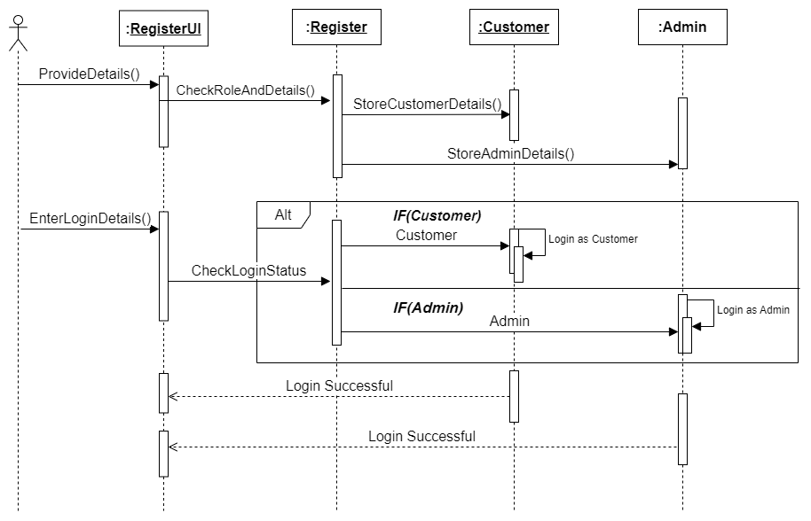

Figure 2: Sequence diagram of Registration

## Sequence diagram of Product, Add to cart, and Product Ordering:

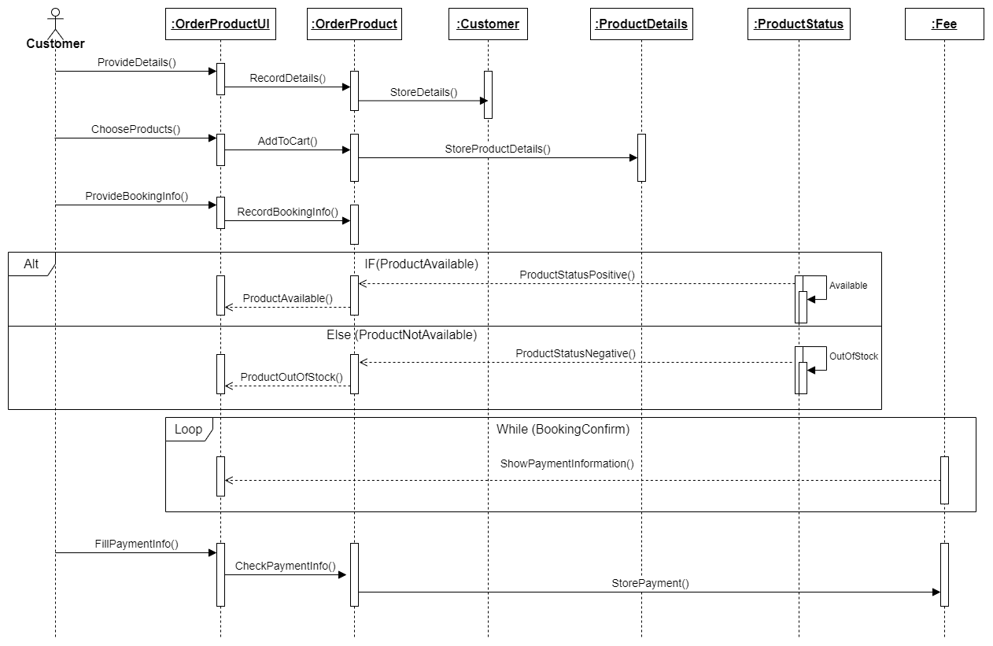

Figure 3: Sequence of Product, Cart, and Product Ordering

## Sequence diagram for Admin Dashboard:

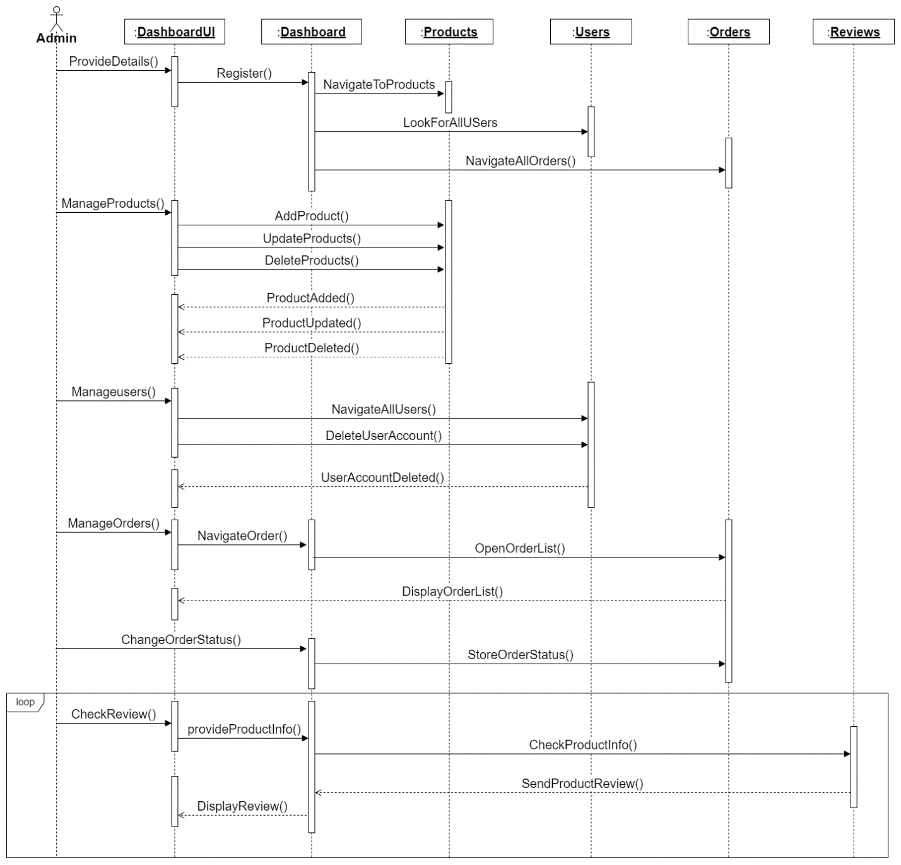

Figure 4: Sequence Diagram of Admin Dashboard

# DATA FLOW DIAGRAM:

## Context Diagram – Level 0 DFD

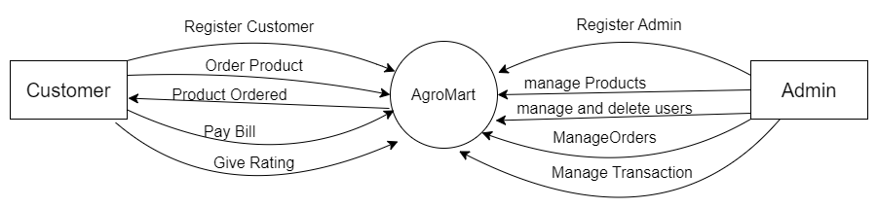

Figure 5: Context Diagram - Level 0 DFD

## Level 1 DFD

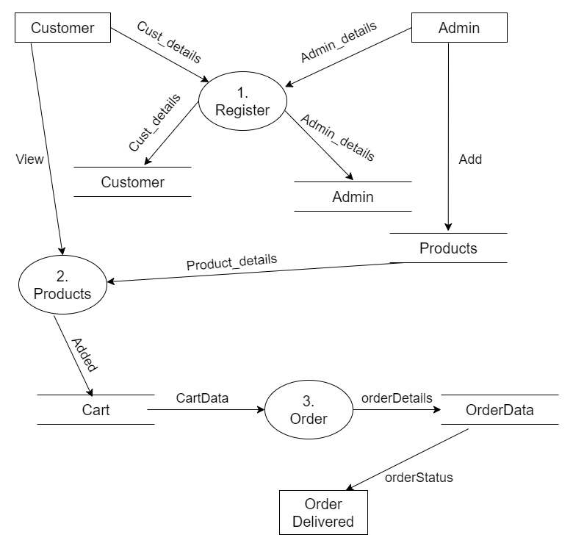

Figure 6: Level 1 DFD

# CLASS DIAGRAM:

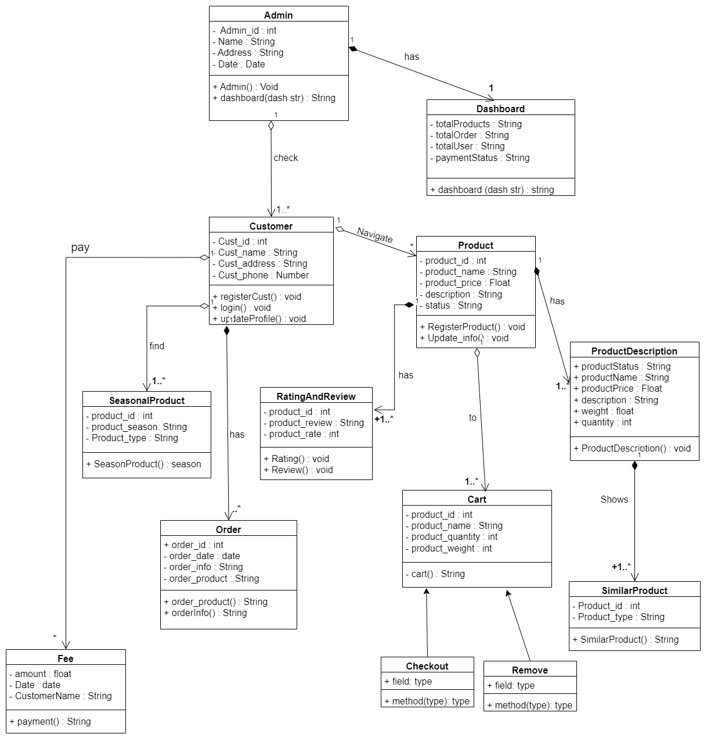

Figure 7: Class Diagram

# ACTIVITY DIAGRAM:

## Activity Diagram – Customer

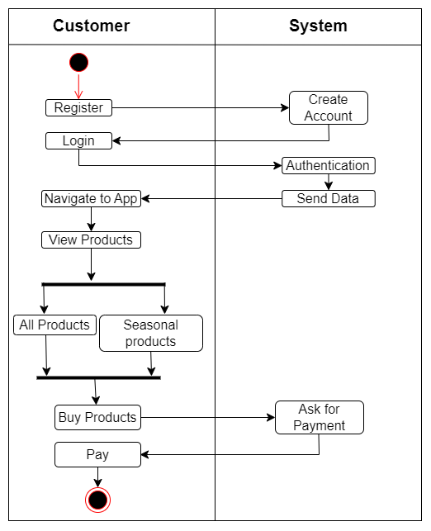

Figure 8: Activity Diagram - Customer

## Activity Diagram – Admin

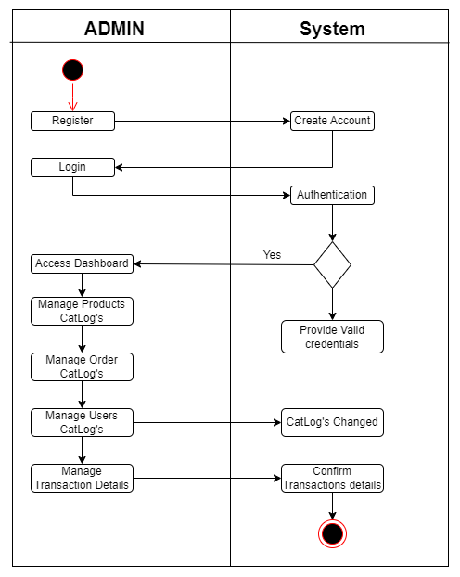

Figure 9: Activity Diagram - Admin

# ENTITY RELATIONSHIP DIAGRAM:

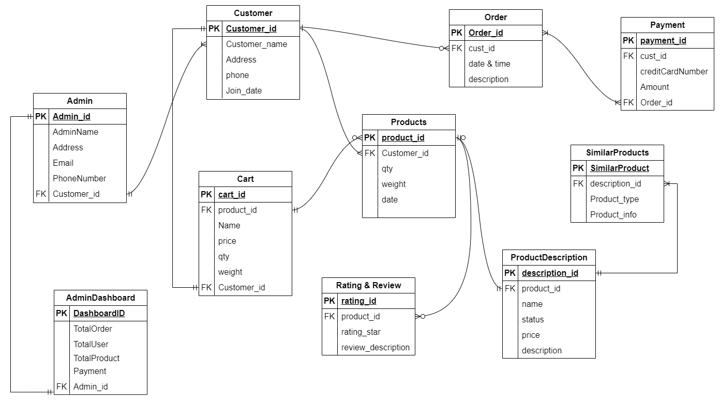

Figure 10: Entity Relationship Diagram

# ARCHITECTURE OF THE SYSTEM:

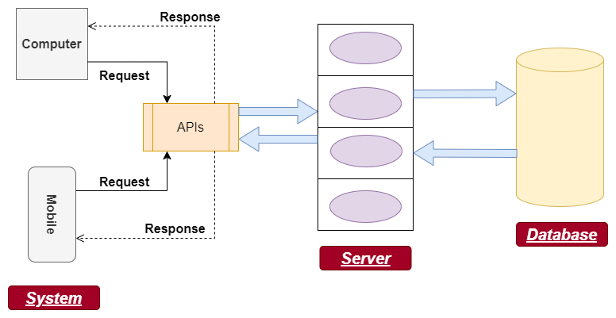

Figure 11: System Architecture

# WIREFRAMES:

## Admin Wireframe

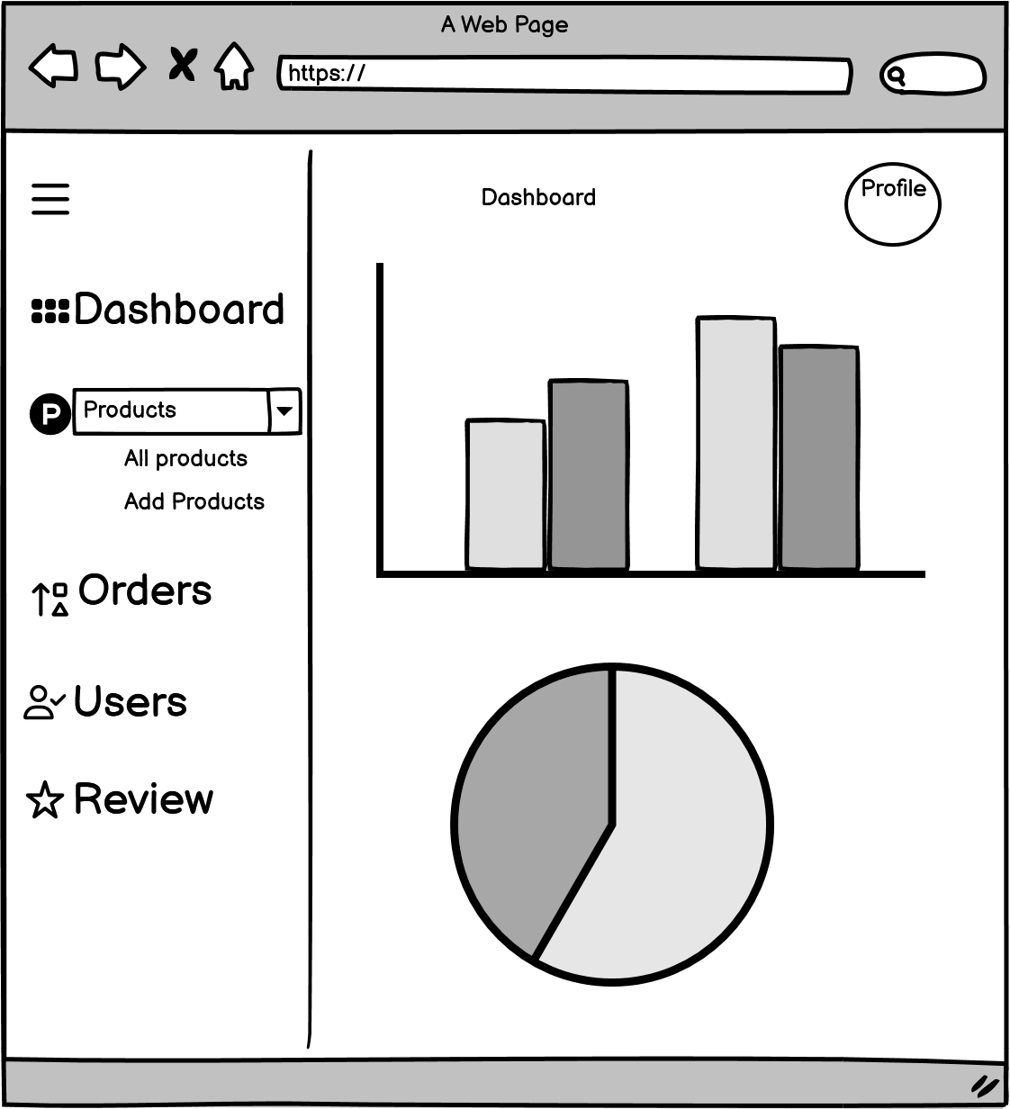

Figure 12: Admin - Dashboard

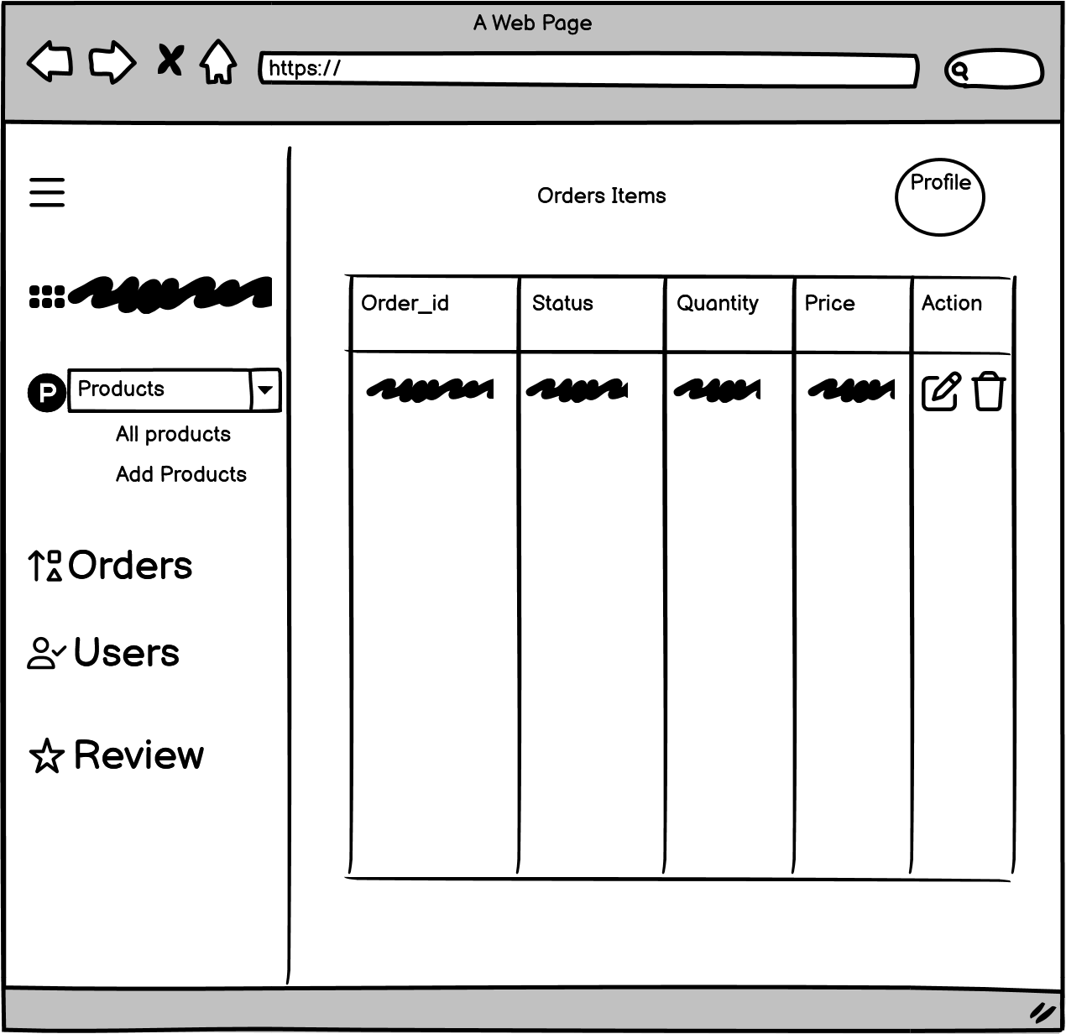

Figure 13: Admin - Order page

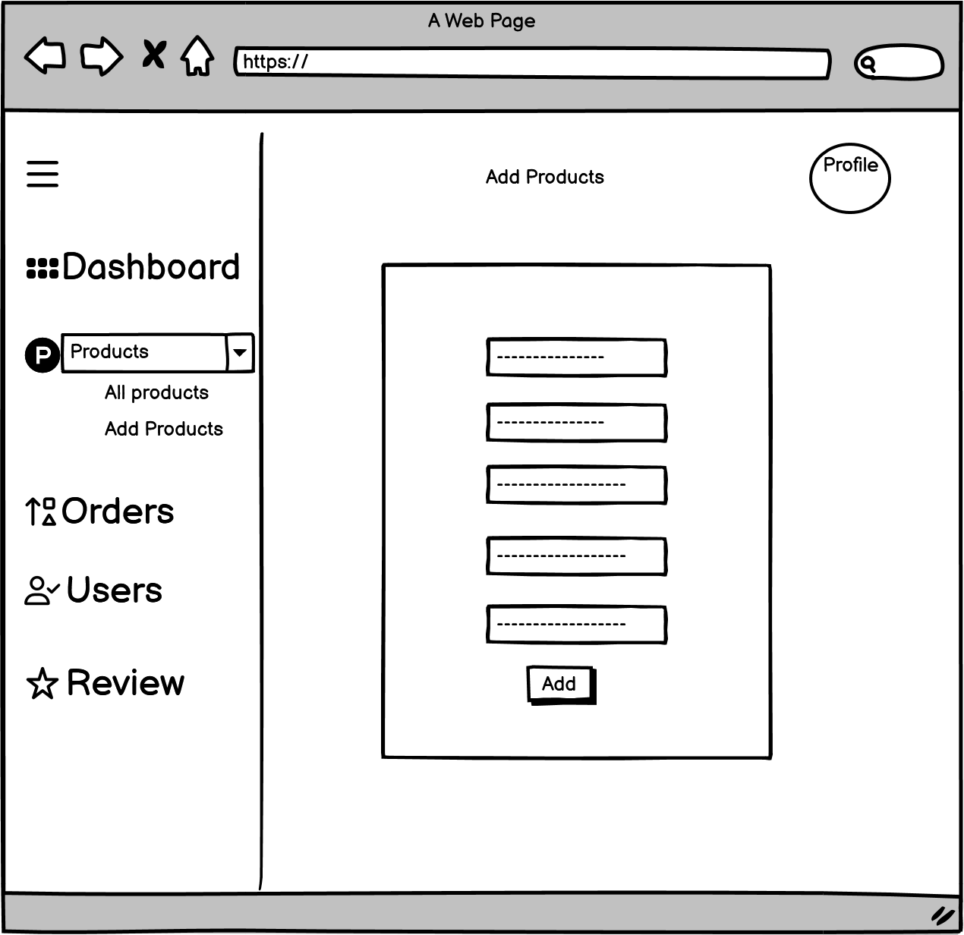

Figure 14: Admin - Add Products

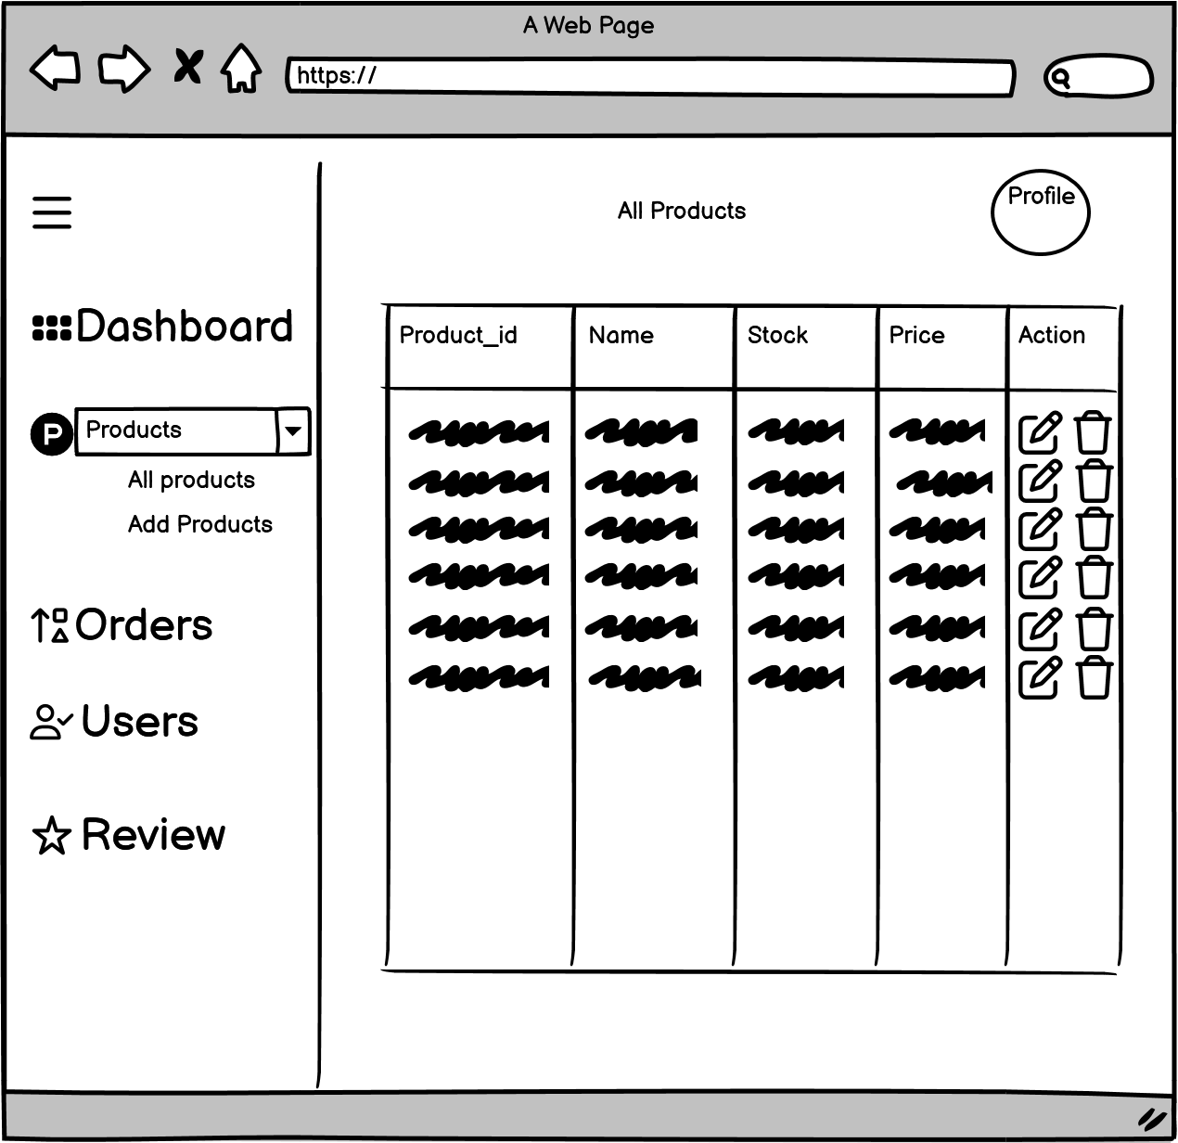

Figure 15: Admin - Product List

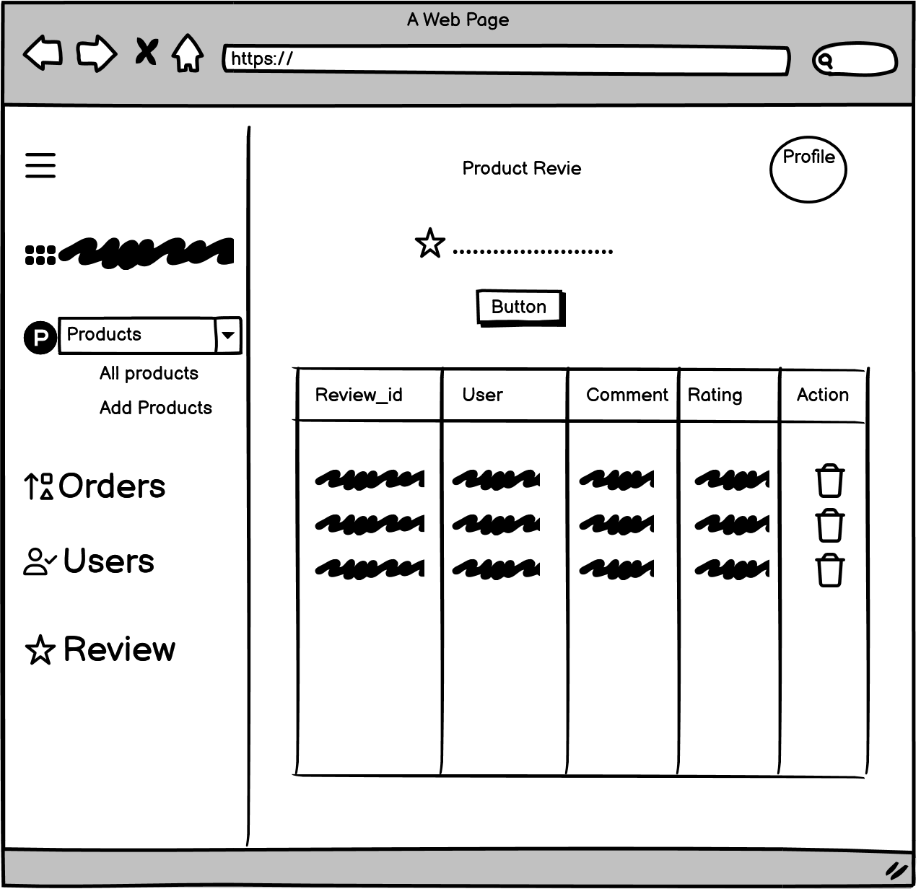

Figure 16: Admin - Review Page

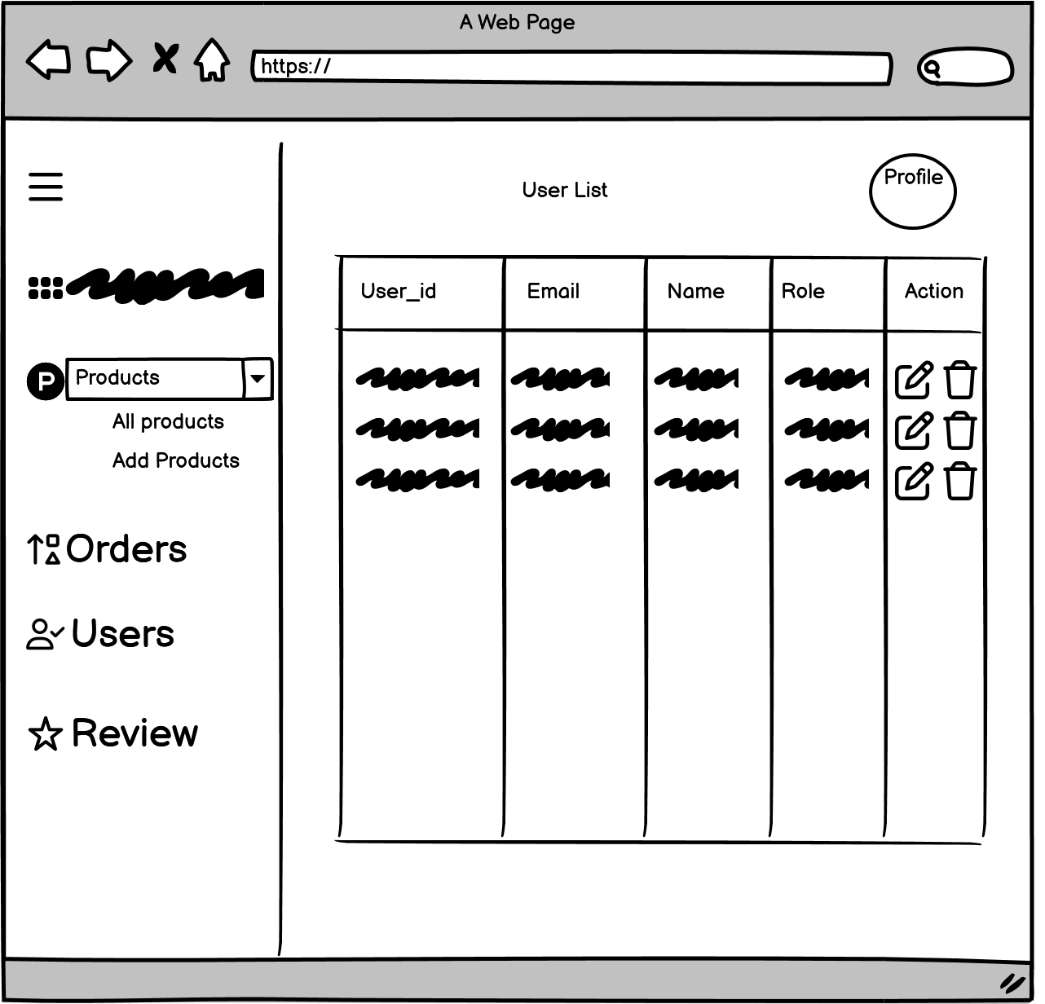

Figure 17: Admin - User List

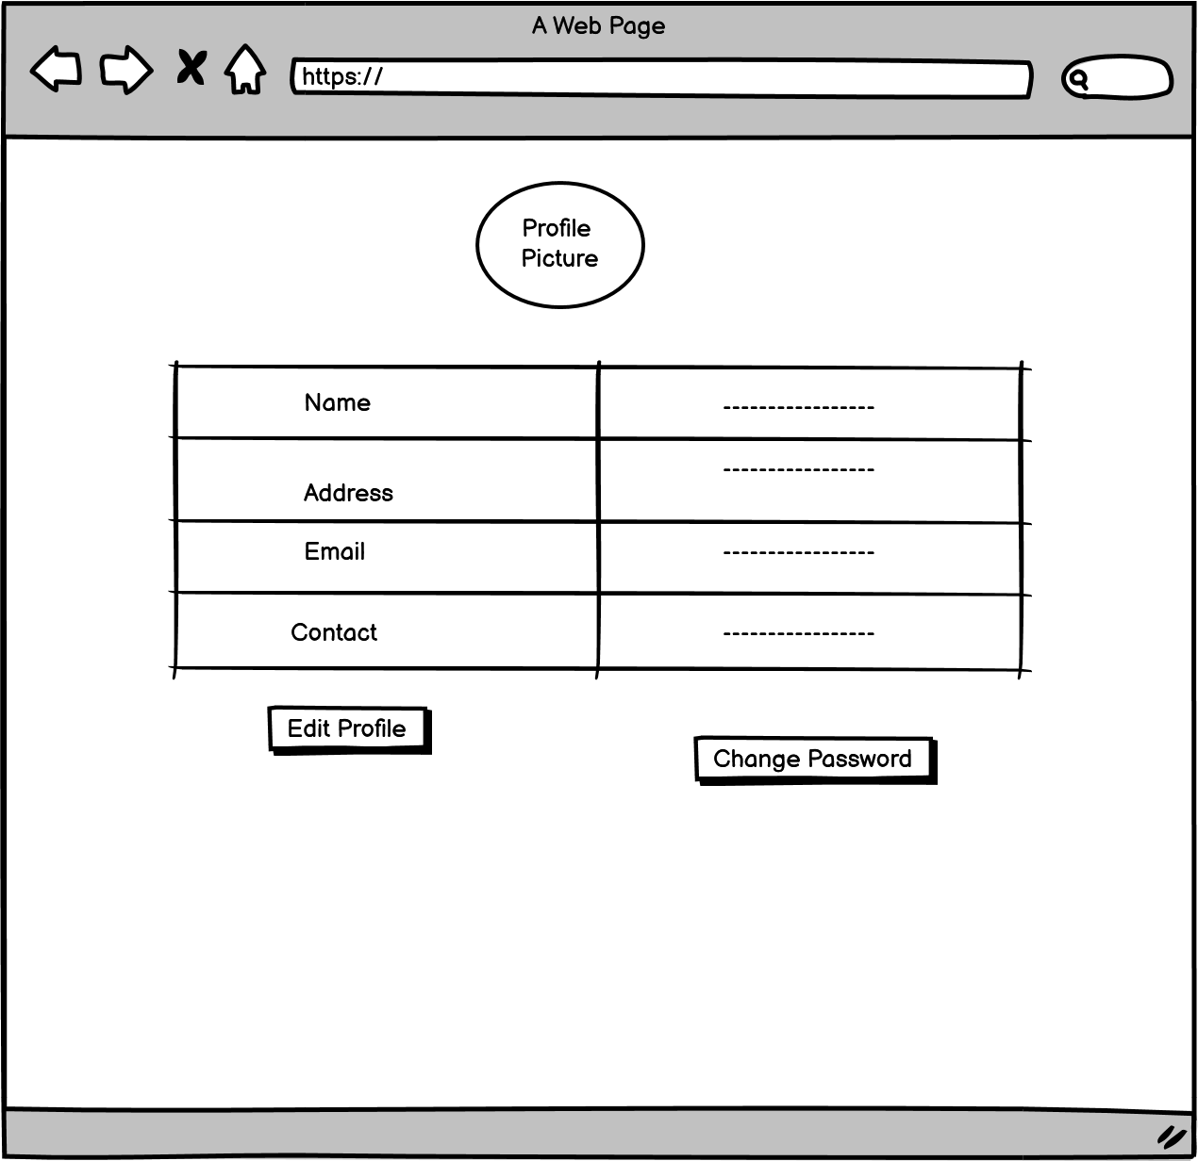

Figure 18: Admin – Profile

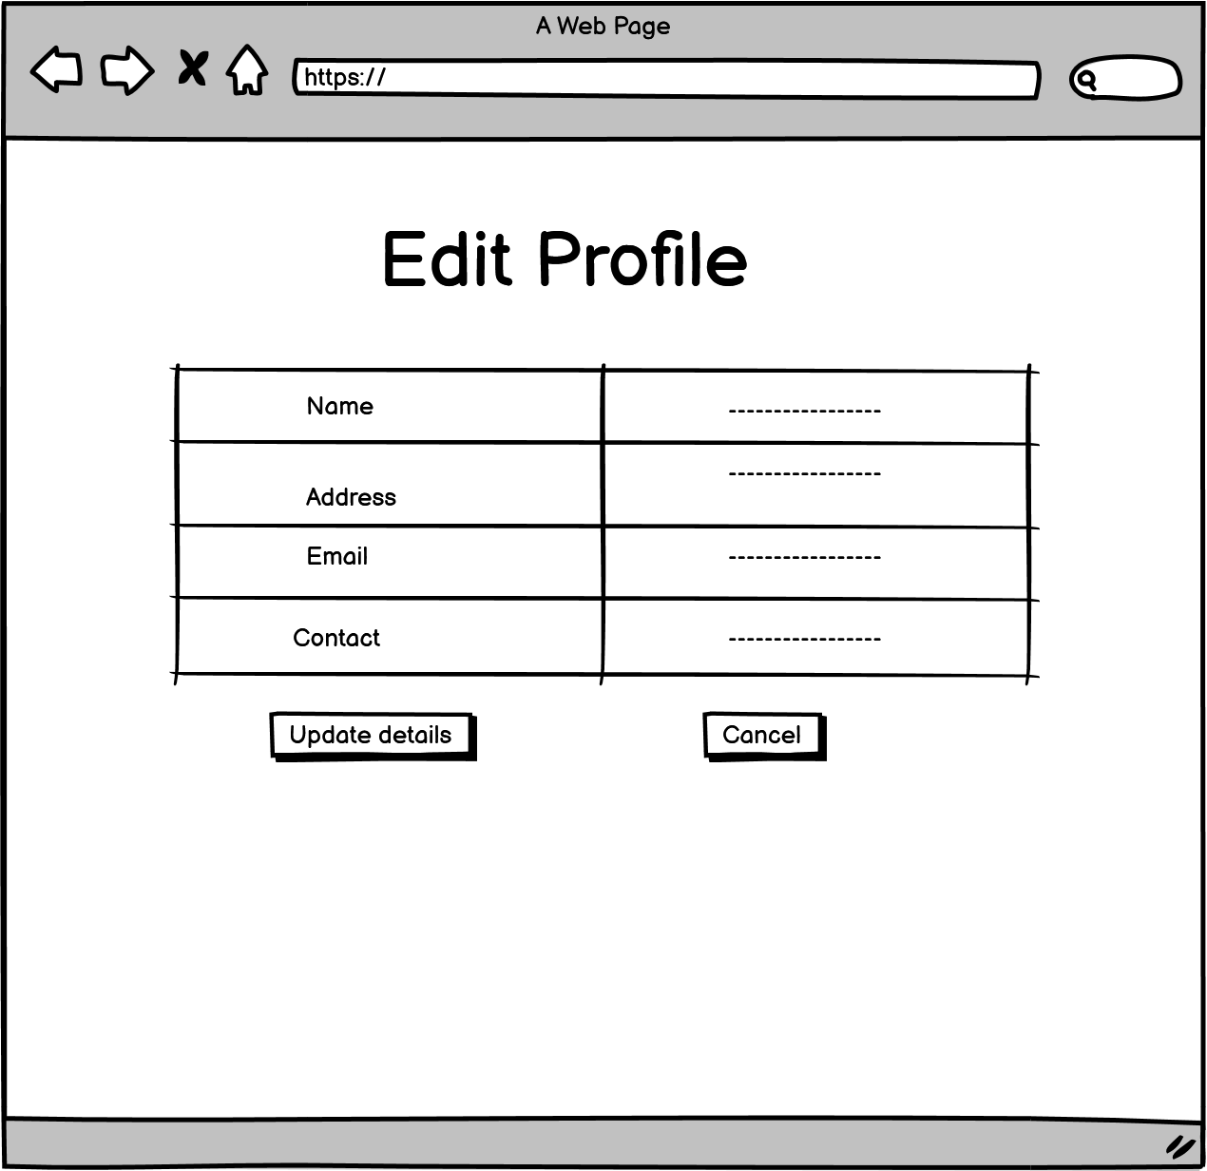

Figure 19: Admin - Edit Profile

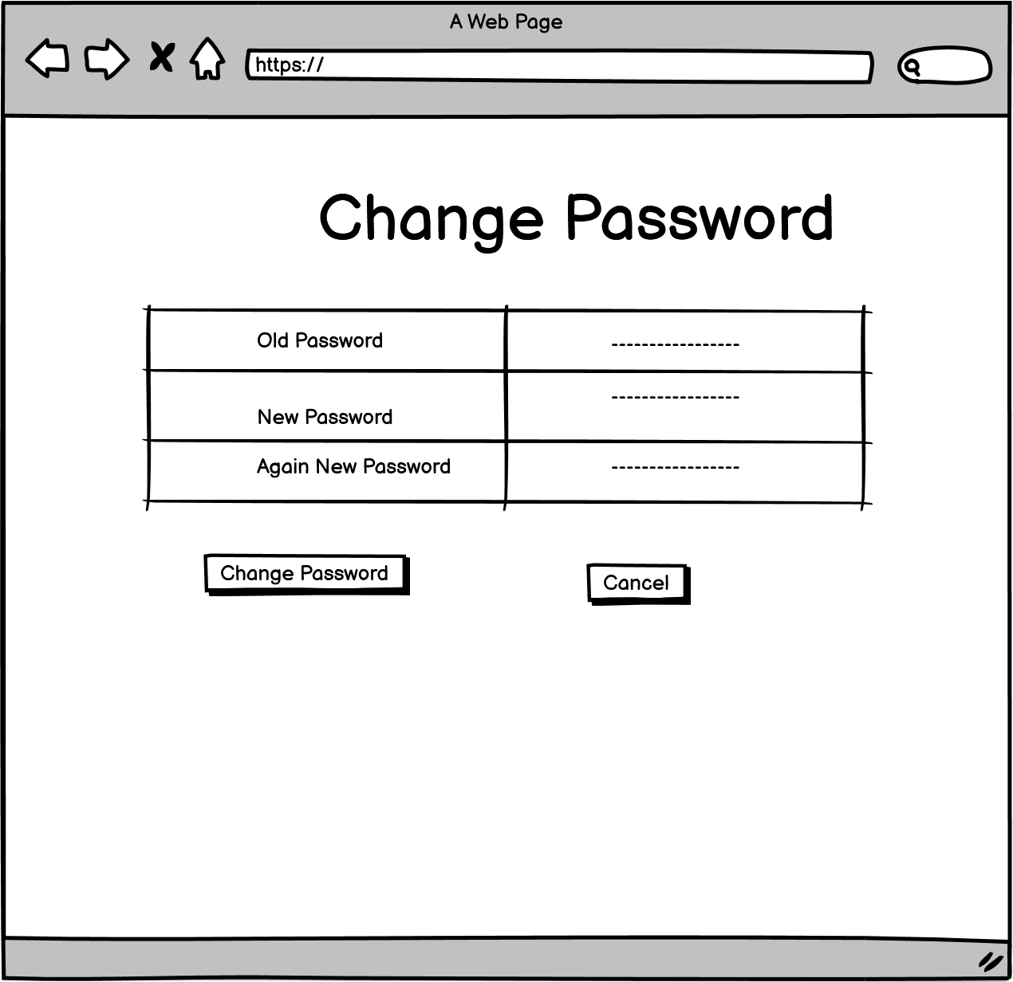

Figure 20: Admin - Change Password

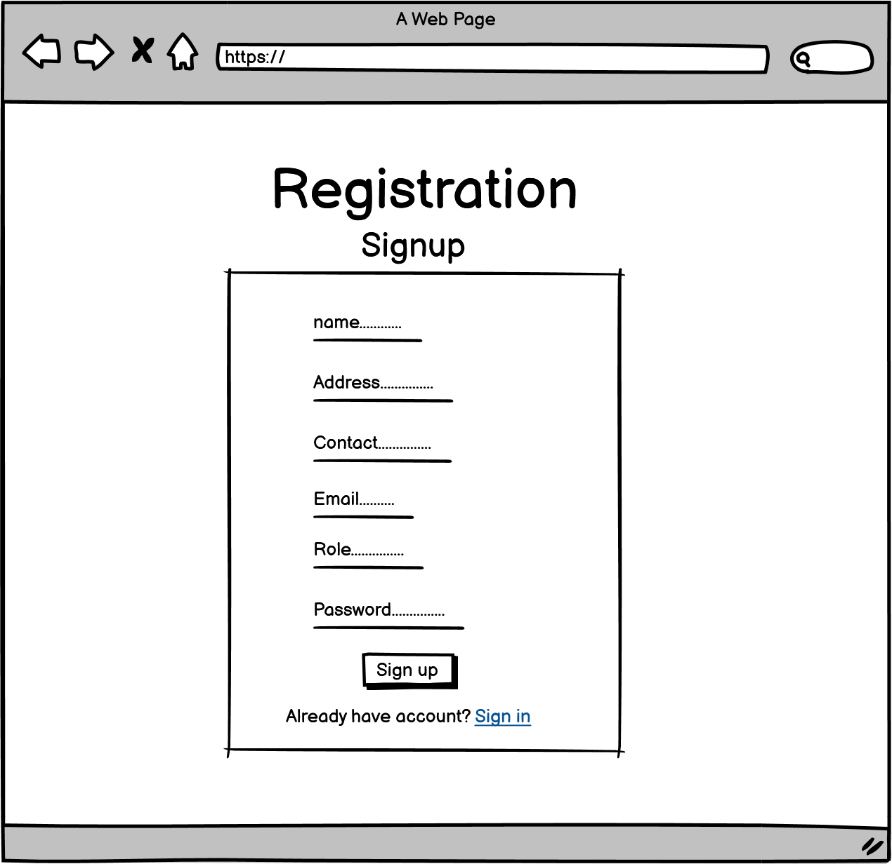

Figure 21: Admin - Registration Signup

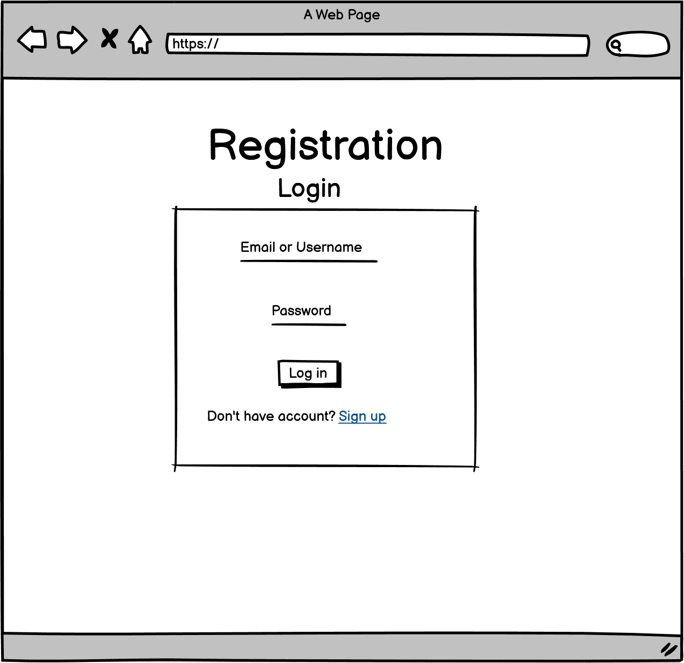

Figure 22: Admin - Registration Login

## Customer Wireframe

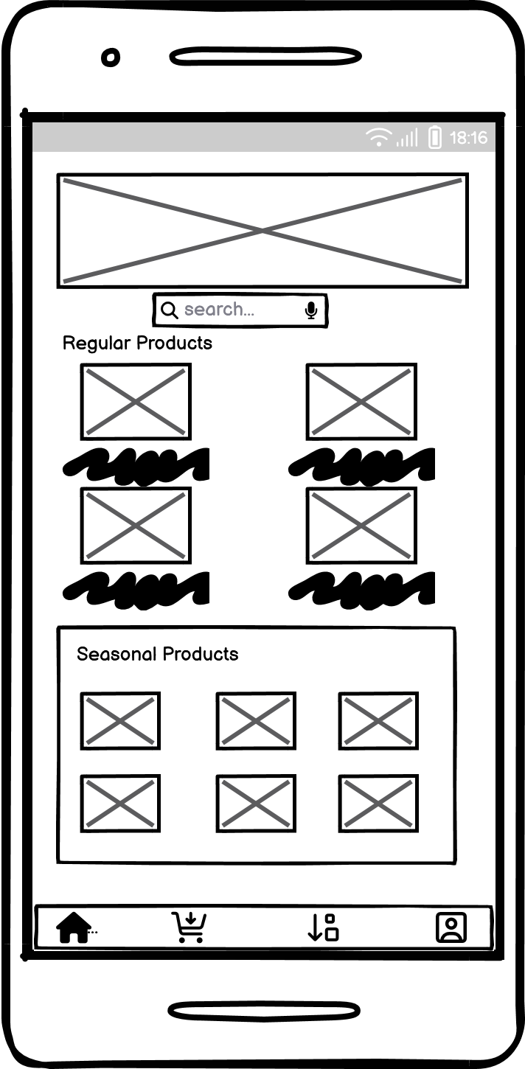

Figure 23: Home Page

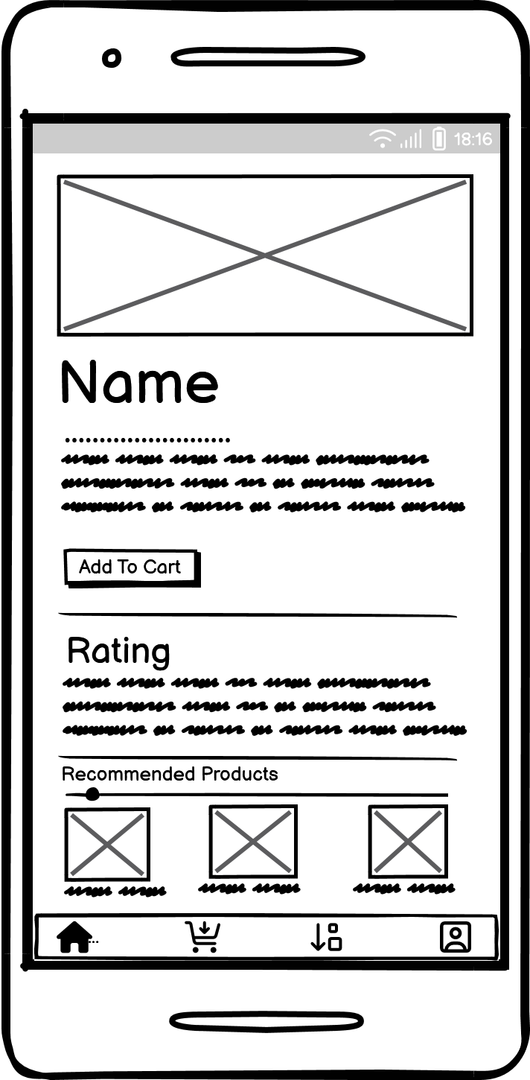

Figure 24: Product Description

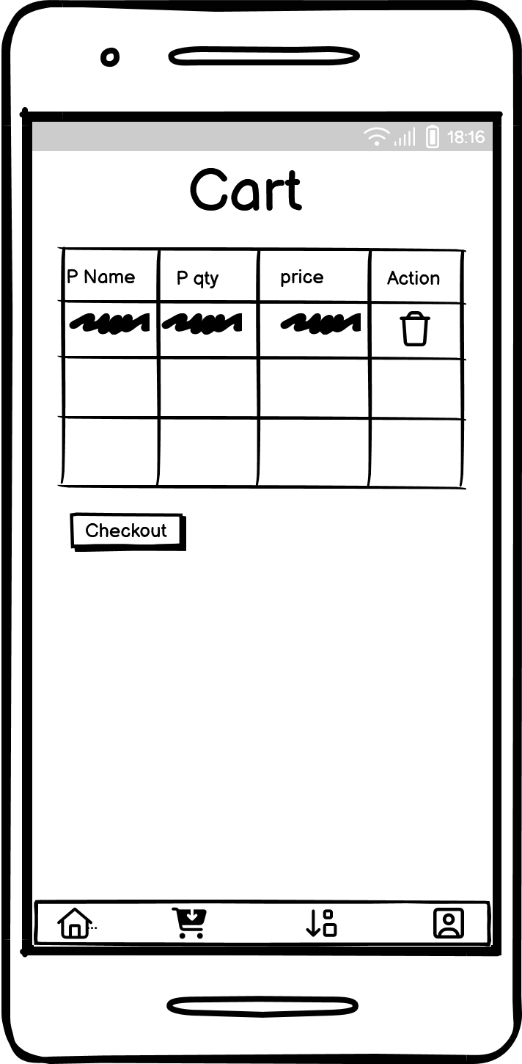

Figure 25: Cart Page

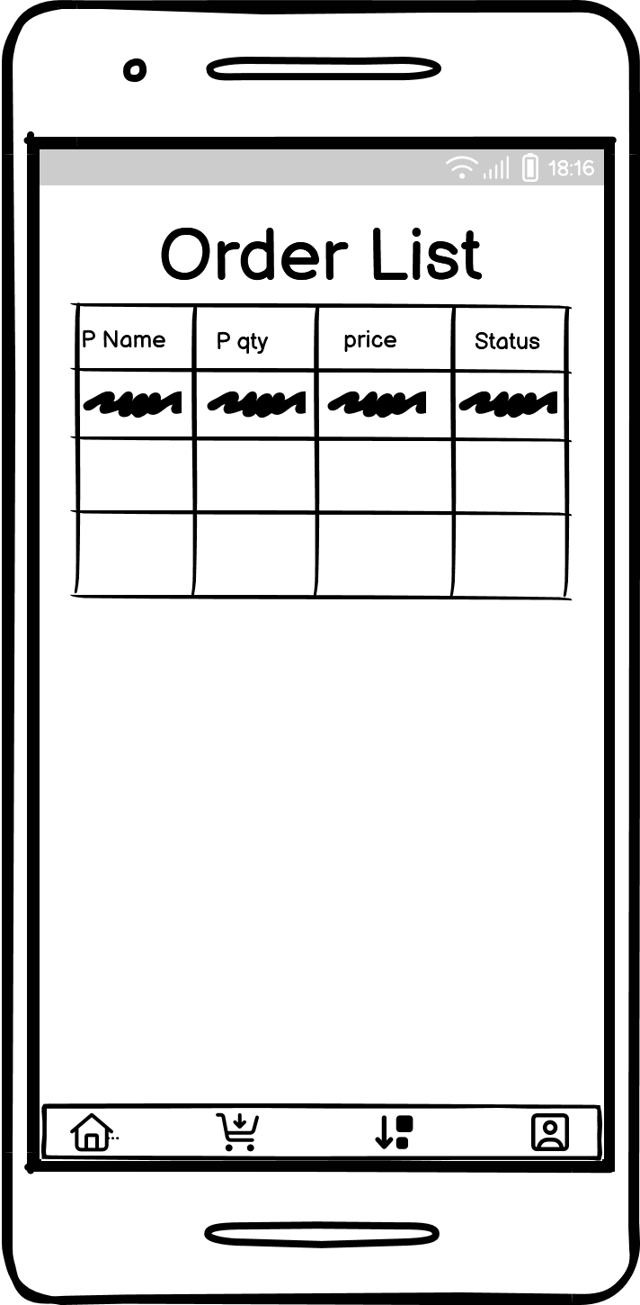

Figure 26: Order List

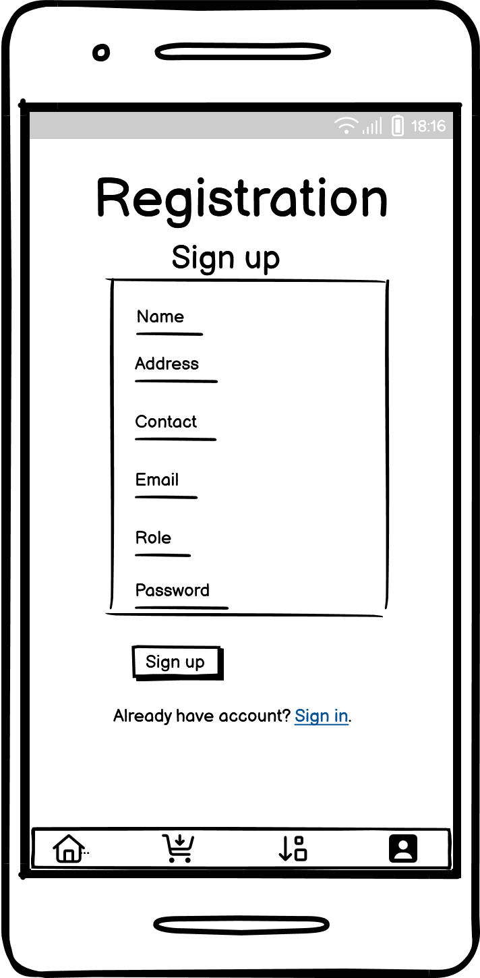

Figure 27: Registration - Sign Up

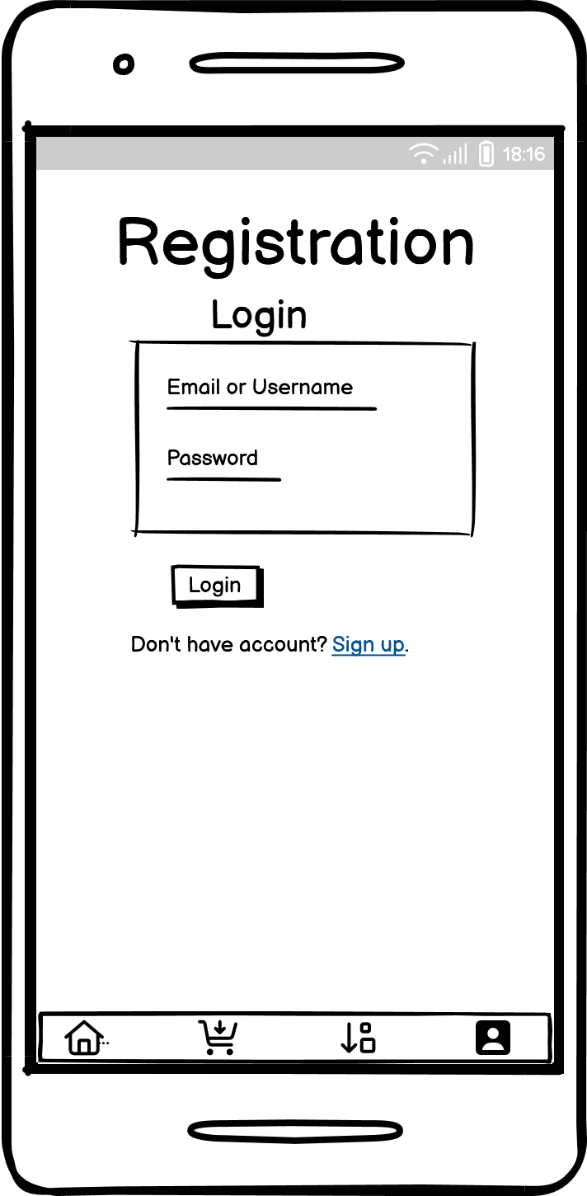

Figure 28: Registration - Sign in

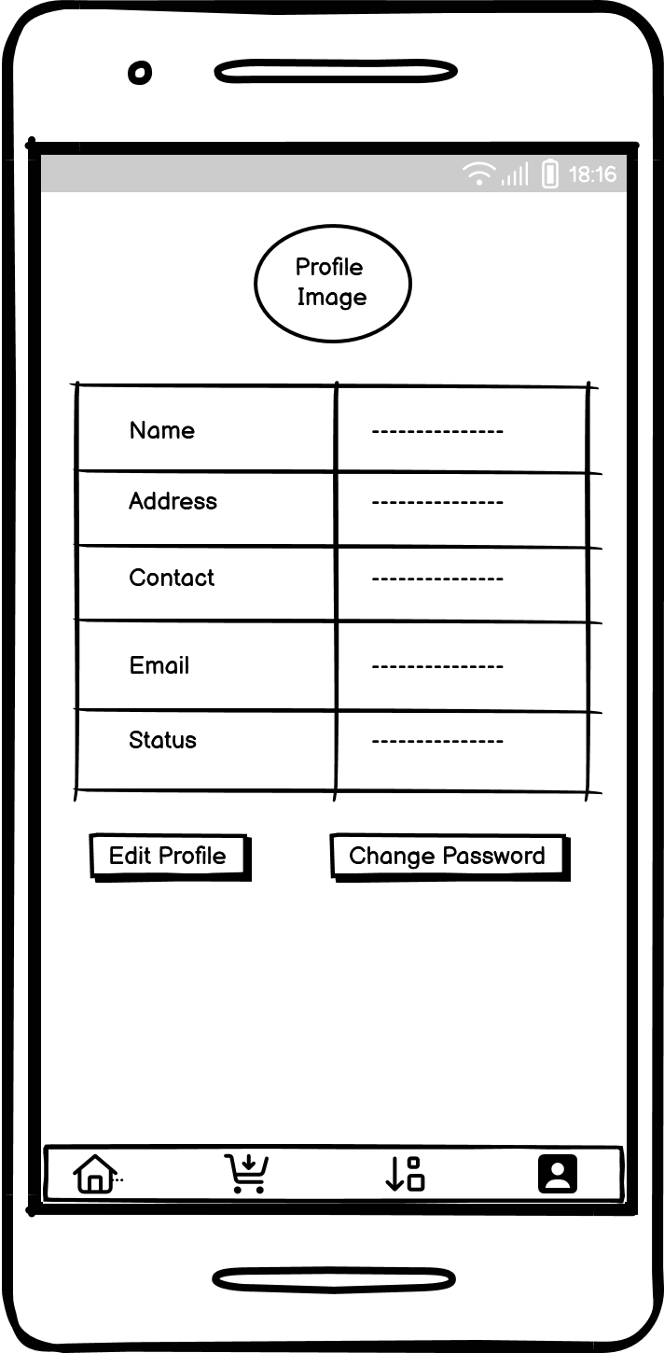

Figure 29: Profile

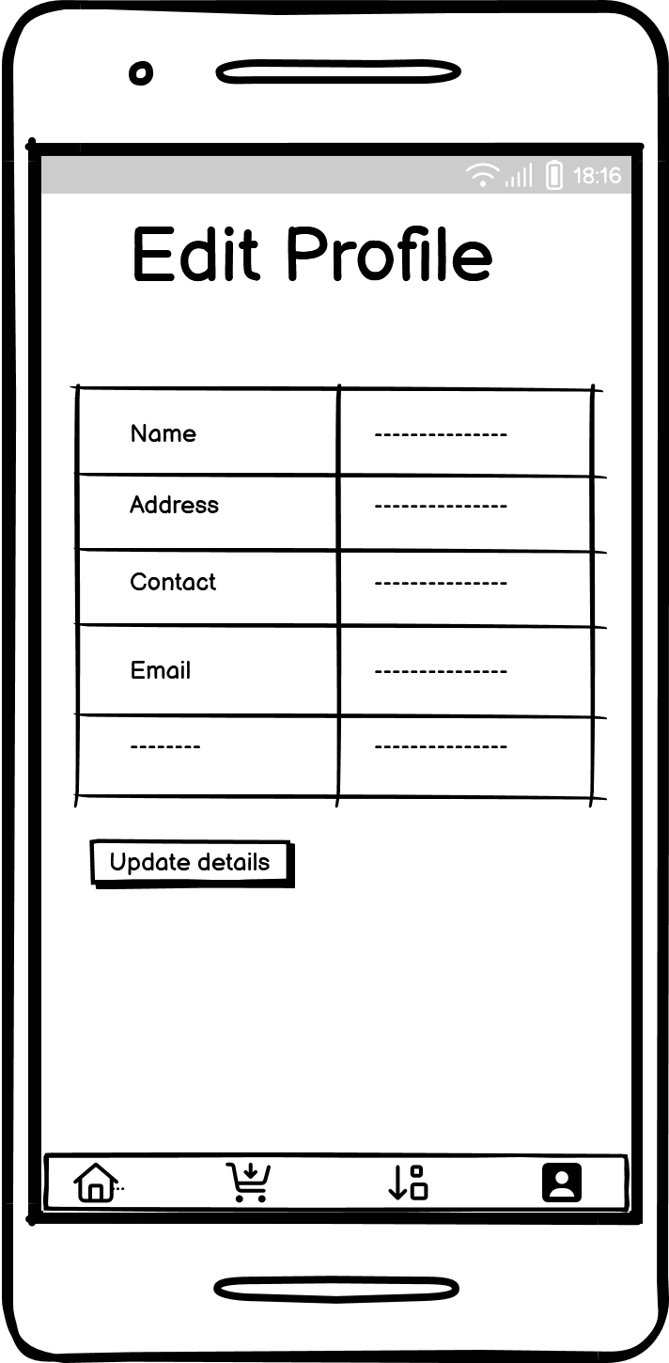

Figure 30: Profile - Edit Profile

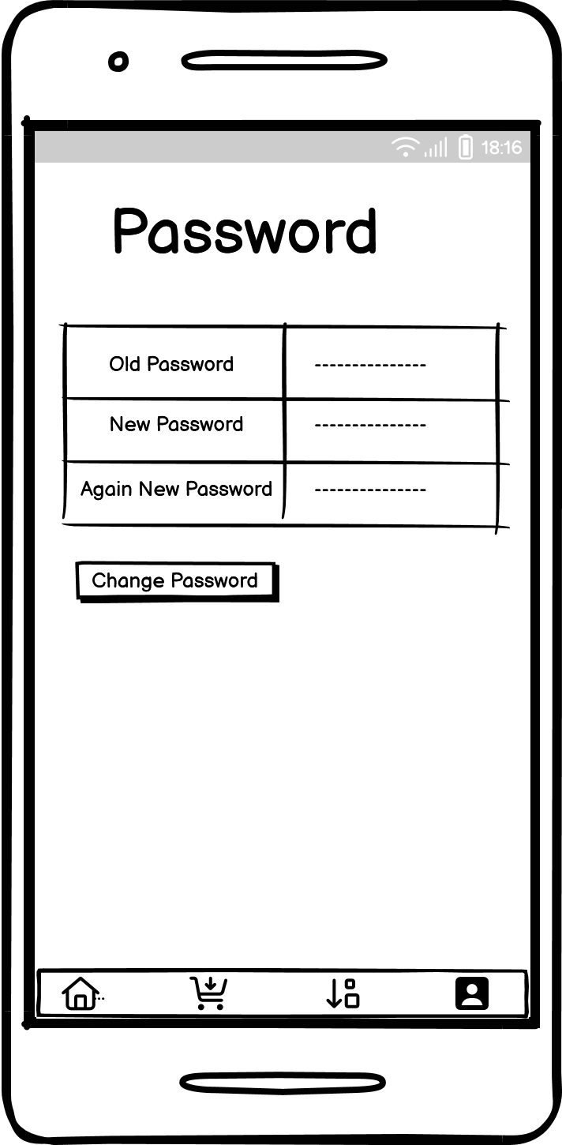

Figure 31: Profile - Change Password